From linear technology and energy supply up to filaments – build with igus components 3D printer
Print your own components for moving applications with the new tribo-filaments from igus

3D printing offers users new ways to print objects with complex designs. This is a good alternative, especially for designers, to manufacture components quickly and inexpensively. igus, the tribo-expert, creates for 3D printers not only suitable components that are lubricant-free and low-priced, but also the right filament. With the iglidur I180-PF, igus now introduces an advanced filament that is even easier to process. With this filament, components for bearing points can also be easily manufactured and used immediately.

After the world's first tribo-filament for 3D printers has been premièred at the Hanover Trade Fair, igus as a specialist for 'plastics in motion' now offers its second filament that has been optimised for friction and wear. "iglidur I180-PF, the new material of our 3D filament, is even easier to process than the iglidur I170-PF material presented at the Hanover Trade Fair, because it has a higher elasticity," says Tom Krause, Product Manager for iglidur tribo-filaments at igus. "It is now already available in 1.75 or 3 millimetre diameter." The tribo-filaments from igus are up to 50 times more abrasion-resistant than materials that are traditionally used in 3D printers. These special materials are the result of years of research conducted in the igus test lab with an area of 1,750 square metres, where all products are tested extensively, so that coefficients of friction and wear, as well as the service life can be reliably predicted and calculated.

Components for 3D printer
It is not only the filaments, but other 'motion plastics' products from igus are also suitable for use in 3D printers for all motions. For instance, the plastics expert has recently released the low-priced solid plastic bearing drylin RJ4JP. The bearing made of wear-resistant igus plastic, iglidur J4, has the dimensions of the so-called compact "Japanese standard", which has in the meantime established itself as a popular size for linear guides in 3D printers. Like all products of the drylin linear and drive systems, the new solid plastic bearing operates completely without external lubrication and maintenance. This results in a further cost advantage, because downtimes through lubrication and maintenance are prevented. The complete drylin E-axes have already established themselves. They are delivered with a pre-fitted electric motor in a variety of designs and can be installed immediately. In addition to bushings, lead screws, guides and linear plain bearings, igus also offers compact energy chains for use in 3D printers. For example, the chains of the E2 micro series, which are available in over 180 different variations. Whether horizontal, vertical, hanging or standing, circular or lateral – the E2 micro can be attached in all directions on the chain and on the machine using various mounting brackets. A chain opener is always included in the delivery for a quick mounting in the snap open models.

Captions:

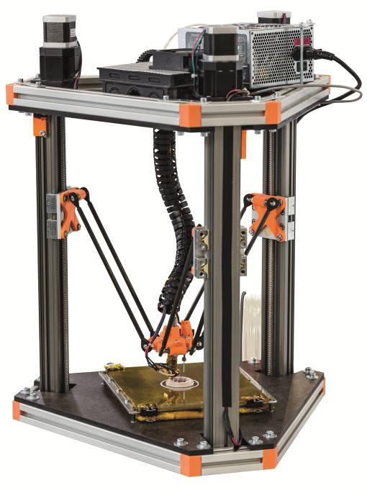
Image PM4014-1
Tribo-expert igus offers several components for 3D printers -- from plain bearings and energy supply systems to friction and wear-optimised filaments. (Source: igus GmbH)

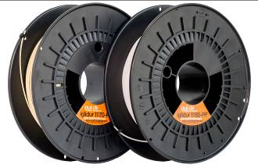
Image PM4014-2
After the world's first tribo-filament for 3D printers has been premièred at the Hanover Trade Fair, igus as a specialist for 'plastics in motion' now offers its second filament that has been optimised for friction and wear. (Source: igus GmbH)

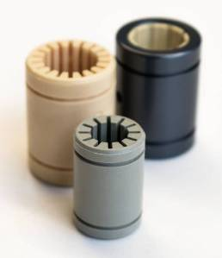
Image PM4014-3
The new greyish solid plastic bearing drylin Rj4JP is available in special dimensions in the so-called "Japanese standard". (Source: igus GmbH)

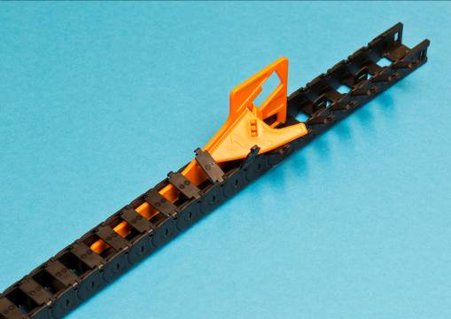
Image PM4014-4
The chains of the E2 micro series are available in over 180 different variations. A chain opener is always included in the delivery for a quick mounting in the snap open models. (Source: igus GmbH)

